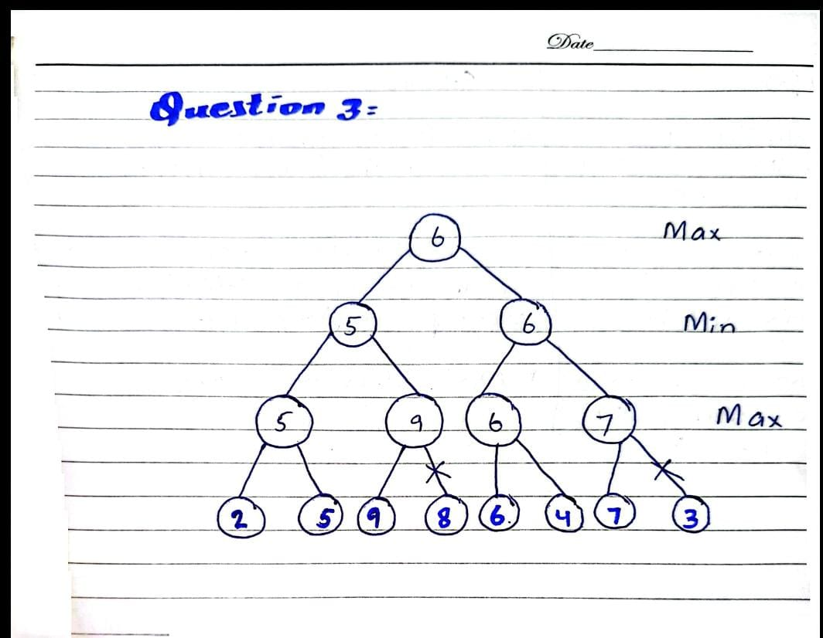
- The root value is 6 in both orders so minmax decision doesnot change when the branches are Reordered.
- The number of evaluated leaves is changed:
- 5 in the original order
- 6 when reordered
- Visit order is [2,5,9,6,4,7]

- Code Output:

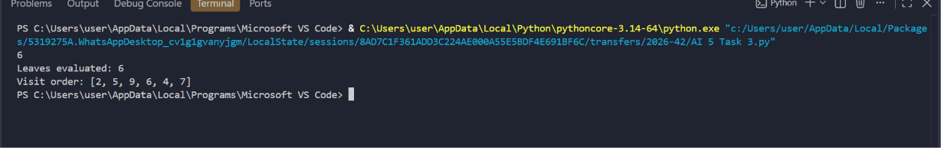
- Difficulties:
I got a name error for count and visited.I set count=0 and visited=[] before calling the function.

